*Protein extraction from alcohol industry residual rice ddgs by alkaline aqueous ethanol method using ultrasonic cell crusher: value added product from waste.*

Aaditya Kumar Pandeya, Abhay Singha, Abhinay Bhatta, Achyutam Arvinda, Aditi Kesharwania, Vitthal L Golea*

a Department of Chemical Engineering, Madan Mohan Malviya University Of Technology, Gorakhpur, Uttar Pradesh, 273010

**Background:**

Bioethanol has expanded massively throughout the years and notwithstanding of the debate of food versus fuel. It has been anticipated to create 42 million metric lots of DDGS (Distillers Dried Grains With Solubles), which is around 14% worldwide crops for ethanol creation ( OECD-FAO Horticultural, 2012). According, the creation of DDGS is huge and is testing mission for refinery ventures to convert bioprocess into high esteem items. Generally, drawn out stockpiling and disposal into environment could cause extreme environmental issues like eutrophication in water bodies and soil barrenness.

DDGS is containing very high concentration of proteins (26-31.7%) compared to lipid and fibre. The extraction of prolamine protein zeins from DDGS has been quite difficult. Extraction at 60% ethanol and 60°C was only capable of extracting 1.5-3.9% of crude zein in ethanol byproducts (Wolf and Lawton, 1997). Alkaline ethanol extraction have shown better extraction of protein from DDGS.

**Abstract:**

Current work explores the protein extraction from rice DDGS by alkaline ethanol extraction method using ultrasonic cell crusher. In this study, protein extraction has been studied under the influence of several parameters; concentration of ethanol, feed ratio, temperature and pH. The method was able to extract 10% protein using ultrasonic cell crusher (power rate 60%, pH 4-5, time 2 hr).

**Experimental Setup**:

*Methodology*

Alkaline aqueous ethanol method has been used in extracting protein from rice DDGS. 10gm of DDGS sample was mixed with 200ml solution of varying concentration of ethanol, followed by ultrasonication of mixture at 30°C for 1hr at 60% power rate. 1M of NaOH solution was freshly prepared in 250 ml distilled water. Now the above treated mixture was mixed with prepared NaOH solution until the mixture attained pH of 11-12 which is required for protein solubility followed by ultrasonication of mixture for 1hr at 60% power rate. After the above treatment, the mixture was centrifuged at 1500rpm for 20min. A separate liquid layer was obtained which contains the protein. This liquid was carefully collected in a beaker and 1M HCL solution was added drop wise until pH of 4-5 was attained. This precipitated the protein which was collected and kept for drying at 40-50°C.

**Table 1: Effects of ethanol concentration on quantity of protein extracted**

|  |  |
| --- | --- |
| **Percent concentration of Ethanol**  **(X-axis)** | **Quantity of protein extracted (gm)**  **(Y-axis)** |
| 40% | 0.1322 |
| 60% | 0.9952 |
| 70% | 0.7797 |
| 90% | 0.4479 |

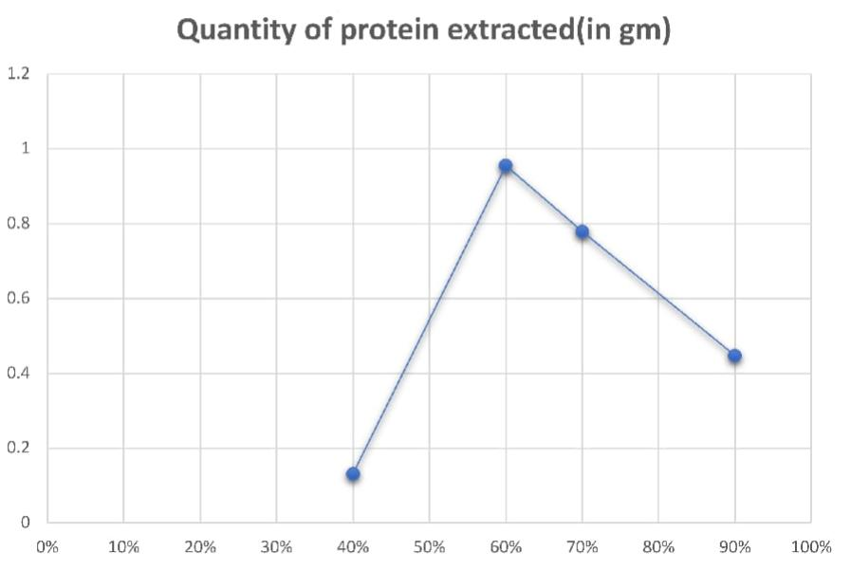**Fig 1. Quantity of extracted protein on different ethanol concentration**

***Major findings:***

* Through alkaline aqueous ethanol method using ultrasonic cell crusher, significant amount of protein can be extracted.
* Conversion of industrial residue into value added products.
* Significant quantity of protein extraction in cost effective manner and less time.

**References:**

[1] Liu, K., 2011. Chemical composition of distillers grains, a review. J. Agric. Food Chem.59, 1508–1526.

[2] Sugimoto, T., Tanaka, K., Kasai, Z., 1986. Improved extraction of rice prolamin. Agric. Biol. Chem. 50, 2409–2411.

[3] Zarrinbakhsh, N., Mohanty, A.K., Misra, M., 2013. Fundamental studies on water washing of the corn ethanol coproduct (DDGS) and its characterization for biocomposite applications. Biomass Bioenergy 55, 251–259. <https://doi.org/10.1016/j.biombioe.2013.02.016>.

[4] Tang, S., Hettiarachchy, N.S., Shellhammer, T.H., 2002. Protein extraction from heat stabilized defatted rice bran. 1. Physical processing and enzyme treatments. J. Agric. Food Chem. 50 (25), 7444–7448.